Endpoints Documented
- patch:\accounts(accountNumber):application\json:bank-account-api-config
- post:\accounts:application\json:bank-account-api-config

Sequence Diagram
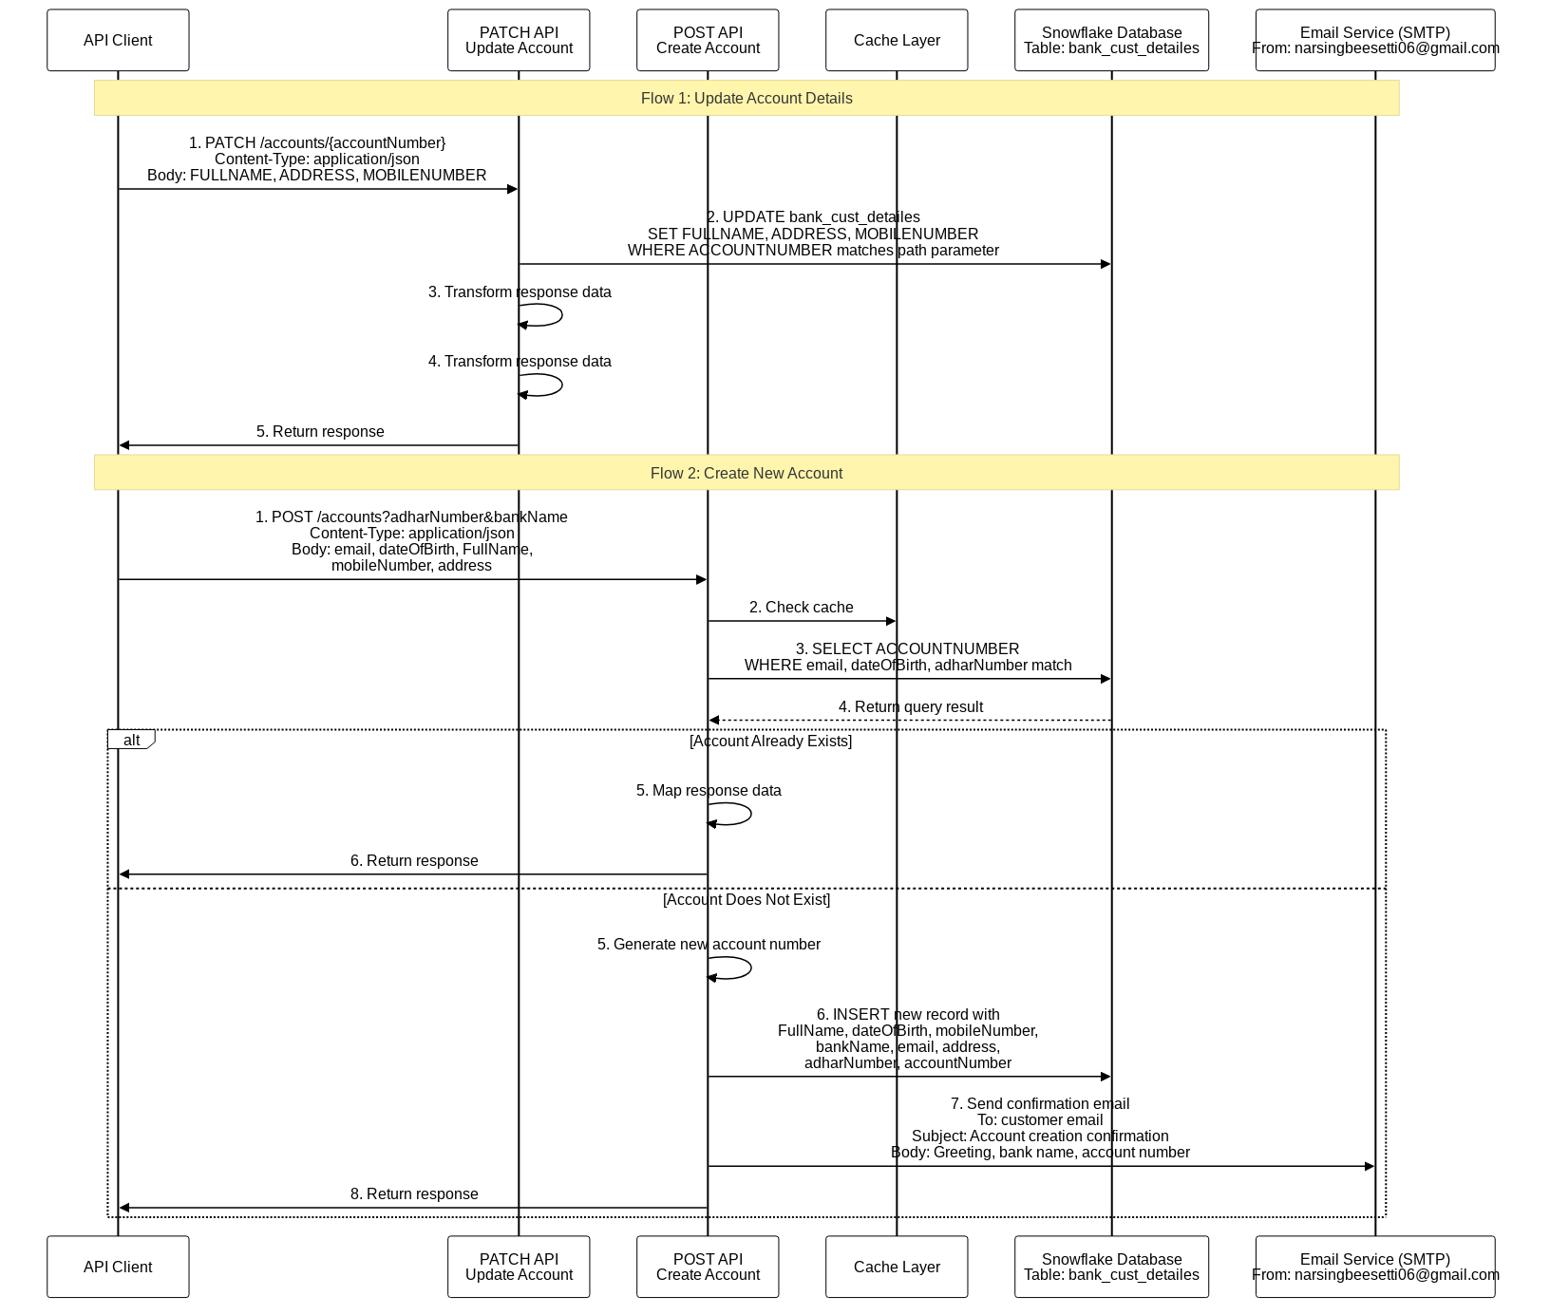

Flow Name
patch:\accounts\(accountNumber):application\json:bank-account-api-config

High Level Summary
This flow is triggered by a PATCH request to the /accounts/{accountNumber} API endpoint, expecting a JSON payload. It updates the bank_cust_detailes table in Snowflake. The accountNumber from the URL and FULLNAME, ADDRESS, MOBILENUMBER from the request body are used for the update. If FULLNAME, ADDRESS, or MOBILENUMBER are missing in the request, they will be set to an empty string. After the database update, two unspecified transformation steps are executed. There is no conditional logic, batching, or explicit error handling configured.

Flow Diagram
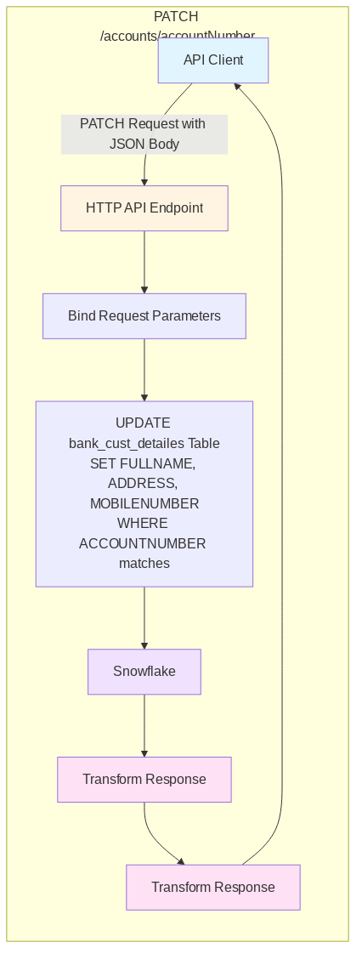

Schema and Input/Output Examples

Schema
{
"type": "object",
"properties": {
"FullName": {
"type": "string"
},
"mobileNumber": {
"type": "string"
},
"email": {
"type": "string"
}
},
"required": []
}

Input Example
{
"FullName": "Updated Name",
"address": "New Address",
"mobileNumber": "9856742613"
}

Output Example
{
"message": "Account details updated successfully",
"accountNumber": "63412021212"
}

Detailed Steps
- Trigger
  - Activated by an HTTP API request using method PATCH.
  - Endpoint path pattern: /accounts/{accountNumber}.
  - Consumes content type: application/json.
- Systems Involved
  - Source: API client invoking the HTTP endpoint.
  - Target: Snowflake data warehouse.
  - Affected database object: table named bank_cust_detailes.
- Request and Parameter Handling
  - The path segment {accountNumber} is used to identify the record to update.
  - The request body is expected to include the following fields used for the update:
    - FULLNAME
    - ADDRESS
    - MOBILENUMBER
  - When any of these fields are absent, a default value of [""] is applied for SQL parameter binding.
- Processing and Data Mapping
  - Executes an SQL UPDATE on the table bank_cust_detailes:
    - Sets:
      - FULLNAME from the request body field FULLNAME.
      - ADDRESS from the request body field ADDRESS.
      - MOBILENUMBER from the request body field MOBILENUMBER.
    - Filters rows by:
      - ACCOUNTNUMBER matching the value provided in the request path.
- Post-Processing
  - Two transformation steps are performed after the database operation; specific transformation logic is not defined in the provided context.
- Conditional Logic
  - No conditional routing or filtering is implemented.
- Execution Model
  - No batching, parallelization, or asynchronous processing is implemented.
- Error Handling and Timeouts
  - No explicit error handling, retry, or timeout configuration is defined in the provided context.
- End-to-End Flow Summary
  - Receive PATCH /accounts/{accountNumber} with a JSON body containing optional FULLNAME, ADDRESS, and MOBILENUMBER.
  - Bind body fields and the path parameter to SQL parameters (using [""] defaults for missing body fields).
  - Update the corresponding record in Snowflake table bank_cust_detailes.
  - Apply two subsequent transformations (logic unspecified).

Mapping Table
Mapping table: Comments: HTTP PATCH request body to Snowflake SQL input parameters
Source Field | isMandatory | Target Field | isMandatory | Rules
payload.FULLNAME | No | FullName | Yes | The 'FullName' field is populated from the 'FULLNAME' field of the input payload. If the 'FULLNAME' field is not present or is null, it defaults to an array containing an empty string.
vars.accountNumber | Unk | accountNumber | Unk | The 'accountNumber' field is populated directly from the 'accountNumber' variable.
payload.ADDRESS | No | address | Yes | The 'address' field is populated from the 'ADDRESS' field of the input payload. If the 'ADDRESS' field is not present or is null, it defaults to an array containing an empty string.
payload.MOBILENUMBER | No | mobileNumber | Yes | The 'mobileNumber' field is populated from the 'MOBILENUMBER' field of the input payload. If the 'MOBILENUMBER' field is not present or is null, it defaults to an array containing an empty string.
Comments: This mapping table describes the transformation of an input payload and a variable into a JSON object. The output is an application/json format.
Mapping table: Comments: Internal variables to HTTP PATCH response JSON
Source Field | isMandatory | Target Field | isMandatory | Rules
vars.accountNumber | True | accountNumber | True | The destination field 'accountNumber' is populated directly from the value of the 'accountNumber' variable.
 | True | message | True | The destination field 'message' is populated with the hardcoded string value Account updated successfully.
Comments: This mapping table describes the transformation of data into a JSON object containing a success message and an account number. The output is in JSON format.

Unit Test Scenarios
- Scenario 1: Successful patch of bank account configuration by setting request payload, HTTP attributes, and outbound headers, invoking the flow, and asserting the resulting payload matches the expected output

Logging
- INFO — Logs a static banner message indicating the start of the flow.
- INFO — Logs the final response payload returned to the client, which contains a success message that the account was updated and the account number from the request.

Flow Name
post:\accounts:application\json:bank-account-api-config

High Level Summary
narsingbeesetti06@gmail.com

Flow Diagram
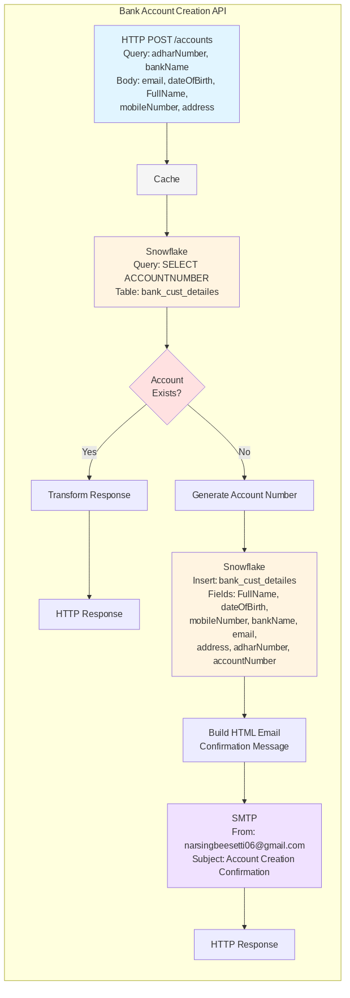

Schema and Input/Output Examples

Schema
{
"type": "object",
"properties": {
"FullName": {
"type": "string",
"required": true
},
"dateOfBirth": {
"type": "date-only",
"required": true
},
"mobileNumber": {
"type": "string",
"required": true
},
"email": {
"type": "string",
"required": true
},
"address": {
"type": "string",
"required": true
},
"adharNumber": {
"type": "string",
"required": false
}
}
}

Input Example
{
"FullName": "Narsingarao Beesetti",
"dateOfBirth": "2000-06-06",
"mobileNumber": "9874561230",
"email": "narsingbeesetti@gmail.com",
"address": "Chowduvada, 123/5"
}

Output Example
{
"message": "Account created successfully",
"accountNumber": "63412021212"
}

Detailed Steps
- Trigger
  - Activated by an HTTP API call using method POST to the path /accounts with Content-Type application/json.
- Inputs
  - Query parameters: adharNumber, bankName.
  - JSON request body fields referenced: email, dateOfBirth, FullName, mobileNumber, address.
- External Systems
  - Database: Snowflake
    - Table: bank_cust_detailes
    - Read operation:
      - SQL: select "ACCOUNTNUMBER" from bank_cust_detailes where email = :email and dateOfBirth = :dateOfBirth and adharNumber = :adharNumber
      - Parameters are sourced from the request body (email, dateOfBirth) and query parameters (adharNumber).
    - Write operation (executed conditionally):
      - SQL: insert into bank_cust_detailes(FullName, dateOfBirth, mobileNumber, bankName, email, address, adharNumber, accountNumber) values (:FullName, :dateOfBirth, :mobileNumber, :bankName, :email, :address, :adharNumber, :accountNumber)
      - Parameters are sourced from the request body (FullName, dateOfBirth, mobileNumber, email, address), query parameters (bankName, adharNumber), and an internally produced account number.
  - Email (SMTP)
    - From address: narsingbeesetti06@gmail.com
    - To: the email address from the request body
    - Subject: Account creation confirmation including the bank name from query parameters
    - Body: HTML message containing a greeting with the requester’s full name, confirmation of the bank name, and the generated account number, plus a non-reply notice.
- Processing Flow
  - Receive POST /accounts with the specified query parameters and JSON body.
  - A caching layer is invoked prior to data verification (no cache key details provided).
  - Verify account existence by querying the database using email, dateOfBirth, and adharNumber.
  - Conditional branch based on the verification result:
    - If records are found:
      - The flow performs an internal mapping step and completes without inserting data or sending email. The response content is not defined in the provided code.
    - If no records are found:
      - An account number is produced internally.
      - Insert a new record into the database with personal details from the request, the bank name and adhar number from query parameters, and the generated account number.
      - Construct an HTML email message confirming account creation and send it to the requester’s email address.
      - The final response content is not defined in the provided code.
- Concurrency and Processing Model
  - Processes one request at a time in a sequential manner; no parallelization, scatter-gather, or batch constructs are present.
- Operational Characteristics
  - No explicit timeouts, retries, or polling intervals are defined.
  - No explicit error handling is defined.
  - Response payload and status codes are not specified in the provided code.

Error Handling
Scenario | Error Code | Response Object/Log Message
Propagate error on APIKIT:BAD_REQUEST | APIKIT:BAD_REQUEST; HTTP 400 | {"message": "Bad request"}
Propagate error on APIKIT:NOT_FOUND | APIKIT:NOT_FOUND; HTTP 404 | {"message": "Resource not found"}
Propagate error on APIKIT:METHOD_NOT_ALLOWED | APIKIT:METHOD_NOT_ALLOWED; HTTP 405 | {"message": "Method not allowed"}
Propagate error on APIKIT:NOT_ACCEPTABLE | APIKIT:NOT_ACCEPTABLE; HTTP 406 | {"message": "Not acceptable"}
Propagate error on APIKIT:UNSUPPORTED_MEDIA_TYPE | APIKIT:UNSUPPORTED_MEDIA_TYPE; HTTP 415 | {"message": "Unsupported media type"}
Propagate error on APIKIT:NOT_IMPLEMENTED | APIKIT:NOT_IMPLEMENTED; HTTP 501 | {"message": "Not Implemented"}

Mapping Table
Mapping table: Comments: HTTP request (query params) to internal variables for Snowflake use
Source Field | isMandatory | Target Field | isMandatory | Rules
attributes.queryParams.adharNumber | Unk | adharNumber | Unk | The  adharNumber  field in the destination is populated directly from the  adharNumber  query parameter found within the  attributes  object of the source.
attributes.queryParams.bankName | Unk | bankName | Unk | The  bankName  field in the destination is populated directly from the  bankName  query parameter found within the  attributes  object of the source.
Comments: This mapping table describes the transformation of query parameters from the attributes object into a JSON output. The output will contain adharNumber and bankName fields.
Mapping table: Comments: HTTP request body to normalized payload variable
Source Field | isMandatory | Target Field | isMandatory | Rules
payload[] | Yes | [] | Yes | The output is a JSON array. The transformation processes the input  payload  , which is expected to be an array. It extracts the last element of the  payload  array using a  reduce  operation. This extracted element then becomes the single element of the output array.
Comments: The overall output is a JSON array. The transformation processes the input payload, which is expected to be an array. It applies a reduce operation to the payload array, where in each step, the current item replaces the accumulator. This effectively extracts the last element from the payload array. This extracted last element is then appended to an initially empty array variable inp, which becomes the final output.
Mapping table: Comments: HTTP request (payload + vars) to Snowflake select input parameters
Source Field | isMandatory | Target Field | isMandatory | Rules
vars.inputAttributes.adharNumber | True | adharNumber | True | The 'adharNumber' field in the destination is directly mapped from the 'adharNumber' field found within the 'inputAttributes' variable.
payload.dateOfBirth | True | dateOfBirth | True | The 'dateOfBirth' field in the destination is directly mapped from the 'dateOfBirth' field of the input payload.
payload.email | True | email | True | The 'email' field in the destination is directly mapped from the 'email' field of the input payload.
Comments: This mapping table describes the transformation of an input payload and variables into a JSON object. The output JSON will contain fields for email, date of birth, and Aadhar number.
Mapping table: Comments: Snowflake select response array to single-record payload
Source Field | isMandatory | Target Field | isMandatory | Rules
payload[] | True | ROOT | Unk | The entire output object is a direct copy of the first element of the input payload array.
Comments: The entire output JSON is the first element of the input payload array.
Mapping table: Comments: Snowflake existing-account record to API response body
Source Field | isMandatory | Target Field | isMandatory | Rules
payload.ACCOUNTNUMBER | Unk | accountNumber | Yes | The 'accountNumber' field is directly mapped from the 'ACCOUNTNUMBER' field within the input payload.
vars.inputAttributes.adharNumber | Unk | adharNumber | Yes | The 'adharNumber' field is directly mapped from the 'adharNumber' field within the 'inputAttributes' variable.
vars.inputAttributes.bankName | Unk | bankName | Yes | The 'bankName' field is directly mapped from the 'bankName' field within the 'inputAttributes' variable.
 | Yes | message | Yes | The 'message' field is a hardcoded string with the value Account already exists.
Comments: This mapping table describes the transformation of input data into a JSON object containing account-related information. The output includes a hardcoded message, an account number derived from the payload, and adhar number and bank name from the inputAttributes variable.
Mapping table: Comments: Generate new account number for downstream insert and response
Source Field | isMandatory | Target Field | isMandatory | Rules
 | Unk | accountNumber | True | The  accountNumber  is generated by first obtaining a random number between 0 (inclusive) and 1 (exclusive). This random number is then multiplied by 10000. The result is rounded down to the nearest whole number. To this integer, the constant value 8569745686 is added. Finally, the resulting sum is converted into a string.
Comments: The DataWeave script transforms data into a JSON object with a single field, accountNumber. The accountNumber is generated using a combination of random number generation and arithmetic operations.
Mapping table: Comments: Internal variables to email body text (notification output)
Source Field | isMandatory | Target Field | isMandatory | Rules
inputPayload.FullName | Yes | output_message | Yes | The destination field is a concatenated string. It starts with the literal string Hi , followed by the full name from the 'FullName' field within the 'inputPayload' variable. This is then followed by the literal string your bank account created successfully in , the bank name from the 'bankName' field within the 'inputAttributes' variable, and finally the literal string and your account number is followed by the value of the 'accountNumber' variable.
inputAttributes.bankName | Yes |  | Yes
accountNumber | Yes |  | Yes
Comments: This DataWeave script concatenates several strings and variables to form a single output message indicating successful bank account creation. The output is a JSON string.
Mapping table: Comments: Internal variables to Snowflake insert input parameters
Source Field | isMandatory | Target Field | isMandatory | Rules
vars.inputPayload.FullName | Yes | FullName | Yes | The 'FullName' field is directly mapped from the 'FullName' field within the 'inputPayload' variable.
vars.accountNumber | Yes | accountNumber | Yes | The 'accountNumber' field is directly mapped from the 'accountNumber' variable.
vars.inputPayload.address | Yes | address | Yes | The 'address' field is directly mapped from the 'address' field within the 'inputPayload' variable.
vars.inputAttributes.adharNumber | Yes | adharNumber | Yes | The 'adharNumber' field is directly mapped from the 'adharNumber' field within the 'inputAttributes' variable.
vars.inputAttributes.bankName | Yes | bankName | Yes | The 'bankName' field is directly mapped from the 'bankName' field within the 'inputAttributes' variable.
vars.inputPayload.dateOfBirth | Yes | dateOfBirth | Yes | The 'dateOfBirth' field is directly mapped from the 'dateOfBirth' field within the 'inputPayload' variable.
vars.inputPayload.email | Yes | email | Yes | The 'email' field is directly mapped from the 'email' field within the 'inputPayload' variable.
vars.inputPayload.mobileNumber | Yes | mobileNumber | Yes | The 'mobileNumber' field is directly mapped from the 'mobileNumber' field within the 'inputPayload' variable.
Comments: This mapping table describes the transformation of various fields from vars.inputPayload, vars.inputAttributes, and vars into a new object. All mappings are direct assignments from the source variables to the destination fields.
Mapping table: Comments: Post-insert success to API response body
Source Field | isMandatory | Target Field | isMandatory | Rules
vars.accountNumber | Unk | accountNumber | Unk | The 'accountNumber' field is populated with the value from the 'accountNumber' variable.
 | True | message | True | The 'message' field is populated with the static string value Account created successfully.
Comments: This mapping table describes the transformation of data into a JSON object containing a success message and an account number.

Unit Test Scenarios
- Scenario 1: Successful account creation path by mocking Snowflake select (account verification) to return a valid result and setting request payload/attributes via set-variable; validates expected payload output
- Scenario 2: Successful insertion of account data by mocking set-variable steps to derive input payload and accountNumber, and mocking Snowflake insert to return a success response; validates expected payload output

Logging
- INFO: A static message is logged to indicate the start of the flow.
- INFO: A static message is logged to indicate execution inside the cache just before the database operation.
- INFO: A static message is logged to indicate that the customer account already exists in the database.
- INFO: The final response payload is logged after successful account creation, including the success message and the generated account number.

Security
<ol> <li> <strong>Snowflake Database:</strong> <ul> <li>Authentication to the Snowflake database is performed using a username and password.</li> <li>Authorization is managed through a pre-defined role within Snowflake.</li> </ul> </li> <li> <strong>Email SMTP (Gmail):</strong> <ul> <li>Authentication to the SMTP server is handled via username and password.</li> <li>The connection to the SMTP server is secured using STARTTLS, which encrypts the communication channel.</li> </ul> </li> </ol>

Constants
Environment | Variable | Value | Description
All | apikit.api | bank-account-api.raml | RAML file loaded by APIkit config bank-account-api-config.
All | apikit.outboundHeadersMapName | outboundHeaders | Variable name used by APIkit to store outbound headers.
All | apikit.httpStatusVarName | httpStatus | Variable name used by APIkit to hold HTTP status code.
All | snowflake.accountName | SBMQKDP-TT42813 | Snowflake account name used by Snowflake_Config connection for all DB operations.
All | snowflake.warehouse | COMPUTE_WH | Snowflake warehouse used by Snowflake_Config for queries/updates/inserts.
All | snowflake.database | MYDATABASE | Snowflake database selected by Snowflake_Config.
All | snowflake.schema | PUBLIC | Snowflake schema selected by Snowflake_Config.
All | snowflake.user | SINGSING | Snowflake username configured in Snowflake_Config.
All | snowflake.role | ACCOUNTADMIN | Snowflake role used by Snowflake_Config.
All | sql.update.table | bank_cust_detailes | Target table for the UPDATE in flow patch:\accounts(accountNumber):application\json:bank-account-api-config.
All | sql.update.columns | FULLNAME, ADDRESS, MOBILENUMBER | Columns updated in the UPDATE statement in the patch flow.
All | sql.update.where | ACCOUNTNUMBER | WHERE clause column used to identify the record in the patch flow.
All | sql.select.account.verify | select "ACCOUNTNUMBER" from bank_cust_detailes where email = :email and dateOfBirth = :dateOfBirth and adharNumber = :adharNumber | Verification SELECT query in post:\accounts flow to check if account exists.
All | sql.insert.table | bank_cust_detailes | Target table for INSERT in post:\accounts flow when creating a new account.
All | sql.insert.columns | FullName,dateOfBirth,mobileNumber,bankName,email,address,adharNumber,accountNumber | Columns inserted into in the post:\accounts flow.
All | email.smtp.host | smtp.gmail.com | SMTP host in Email_SMTP config used by email:send in post:\accounts flow.
All | email.smtp.port | 587 | SMTP port in Email_SMTP config.
All | email.smtp.user | narsingbeesetti06@gmail.com | SMTP username in Email_SMTP config.
All | email.smtp.starttls.enable | true | JavaMail property enabling STARTTLS in Email_SMTP config.
All | email.fromAddress | narsingbeesetti06@gmail.com | From address used by email:send in post:\accounts flow.
All | email.subject.prefix | Account created successfully in - | Constant prefix used in the email subject expression in post:\accounts flow.
All | email.body.contentType | text/html | Content type set on email body in email:send for post:\accounts flow.
All | email.body.encoding | UTF-8 | Encoding set on email body in email:send for post:\accounts flow.
All | template.email.html | <html><head><style>body { text-align: center; } table { margin: 0 auto; height: 20vh; width: 40vh; } h1 { color: green; } h6 { color: red; }</style></head><body><h1>Welcome</h1><h3>#[vars.emailBody]</h3><h6>Note: This is an automated email. Please do not reply to this email.</h6></body></html> | Static HTML template used by parse-template to build the email body in post:\accounts flow.
All | msg.emailBody.prefix1 | Hi | Static text used in constructing vars.emailBody in post:\accounts flow.
All | msg.emailBody.middle | your bank account created successfully in | Static text used in vars.emailBody concatenation in post:\accounts flow.
All | msg.emailBody.suffix | and your account number is | Static text used in vars.emailBody concatenation in post:\accounts flow.

